**“COSY AIR-CONDITONERS”**

**“Panasonic”**

**“Models”**

**“Panasonic 1 Ton YC12”**

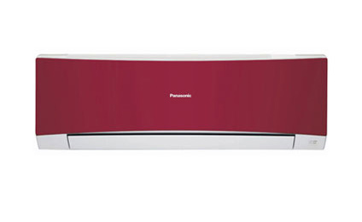

**Specification**

**Capacity (Tonnage) ~** 1

**Capacity (Watts) ~** 3360

**Energy Efficiency (EER) ~** 3.05

**Operating Current ~** 5

**Power Consumption ~** 1100

**Dehumidification ~** Yes

**Odour- Removing Function ~** Yes

**RS ~ 44,500.**

**“Panasonic 1 Ton CS-PC12MKF EcoNavi”**

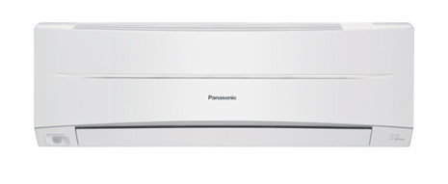

**FEATURES**

* ECONAVI Mono Sensor
* Super Tropical

**Specification**

**Cooling ~** 12,000 Btu/h

**Running Current A ~** 5.7 - 5.5

**Power Input W ~** 1,210 - 1,240

**EER ~** 9.9 - 9.7

**RS ~ 47,000.**

**“Panasonic 2 Ton CS-PC24MKF EcoNavi”**



**FEATURES**

* ECONAVI Mono Sensor
* Super Tropical

**Specification**

**Cooling ~** 24,000 Btu/h

**Running Current A ~** 12.4 - 12.3

**Power Input W ~** 2,570 - 2,700

**EER ~** 9.34 - 8.89

**RS ~ 74,000.**

**“Panasonic 2 Ton YC 24MKF”**



**FEATURES**

* Odour-Removing Function
* Wide & Long Airfloe Vane
* Airflow Direction Control Up & Down
* Wall Mount Split
* Made In Malaysia
* **Specification**
* **Cooling capacity**
* 2.0 ton
* **Cooling type**
* cool only
* **Technology**
* conventional
* **Compressor type**
* Rotary
* **Air-conditioner type**
* Wall mounted split air-conditioner
* **Operating current**
* 11-12 amperes
* **Room / Area**
* 290 square feet
* **Color**
* White
* **Cooling gas**
* R22 (Chinese gas)

**RS ~ 73,000.**